

**CAPSTONE PROJECT I**

CMU-SE 450

**DATABASE DESIGN**

Version 1.0

Date: March 8th, 2021

**FACIAL IDENTIFICATION MATCHING**

**Submitted by**

**Tran, Tran Thi Thuy**

**Han, Hoang Gia Bao**

**Trang, Tran Thi Huyen**

**Kieu, Dinh Thi Van**

**Vi, Pham Ha**

**Approved by**

**Trang, Nguyen Thi Bao M.Sc.**

Proposal Review Panel Representative:

Name Signature Date

Capstone Project 2- Mentor:

Name Signature Date

|  |  |  |  |
| --- | --- | --- | --- |
| **PROJECT INFORMATION** | | | |
| **Project acronym** | FIM System | | |
| **Project title** | Facial Identification Matching web application | | |
| **Start date** | March 1st, 2021 | **End Date** | Jun 2nd, 2021 |
| **Lead institution** | International School, Duy Tan University | | |
| **Project mentor** | Trang, Nguyen Thi Bao M. Sc  Email: nguyenthibaotrang@gmail.com  Phone: 0915 774 711 | | |
| **Product owner & Contact Detail** | Trang, Nguyen Thi Bao M. Sc  Email: nguyenthibaotrang@gmail.com  Phone: 0915 774 711 | | |
| **Partner organization** | Duy Tan University | | |
| **Scrum Master** | Tran, Tran Thi Thuy | tranthuy1944@gmail.com | 090 505 7851 |
| **Team members** | Han, Hoang Gia Bao | baohanhoang2606@gmail.com | 093 563 8848 |
| Trang, Tran Thi Huyen | tranthihuyentrang7251@gmail.com | 037 495 7251 |
| Kieu, Dinh Thi Van | dinhvankieu199@gmail.com | 089 985 2540 |
| Vi, Pham Ha | Phamhavi255@gmail.com | 032 657 7627 |

|  |  |  |  |
| --- | --- | --- | --- |
| **DATABASE DESIGN DOCUMENT** | | | |
| **Document Title** | Database Design Document | | |
| **Author(s)** | HIT LIST Team | | |
| **Role** |  | | |
| **Date** | March 8th, 2021 | **File name:** | [FIM]DatabaseDesign_ver1.0 |
| **URL** |  | | |
| **Access** | Project and CMU Program | | |

|  |  |  |  |
| --- | --- | --- | --- |
| **REVISION HISTORY** | | | |
| **Version** | **Person(s)** | **Date** | **Description** |
| **1.0** | All members | March 8th, 2021 | Create Document |

|  |  |  |  |
| --- | --- | --- | --- |
| **SIGNATURE**  **Document Approvals:** The following signatures are required for approval of this document. | | | |
| **Mentor & Product owner** | Trang, Nguyen Thi Bao M. Sc | **Signature:** |  |
| **Date:** |  |
| **Scrum master** | Tran, Tran Thi Thuy | **Signature:** |  |
| **Date:** |  |
| **Team member(s)** | Han, Hoang Gia Bao | **Signature:** |  |
| **Date:** |  |
| Trang, Tran Thi Huyen | **Signature:** |  |
| **Date:** |  |
| Kieu, Dinh Thi Van | **Signature:** |  |
| **Date:** |  |
| Vi, Pham Ha | **Signature:** |  |
| **Date:** |  |

**Contents**

1. Introduction 6

1.1. Purpose 6

1.2. Scope 6

2. Hardware and Software requirement 7

3. Database Design 7

3.1. Collection Overview 7

3.2. Specified Properties 7

3.3. Firebase JSON Structure 8

3.4. Details 9

3.4.1. CriminalRecord 9

3.4.2. Guilty 10

3.4.3. Admin 10

1. **Introduction**
   1. **Purpose**

* Setting up an overview about the database of Facial Identification Matching web application.
* Provides a database tables and the relationship between them.
* Description designing a database (DB), a collection of data related to storage on a computer through database management system as a basis for data query related software.
* Provide the entire needed database for Facial Identification Matching web application.
  1. **Scope**
* This Database Design Document provides the basic database design of Facial Identification Matching web application.
* It describes both logical and physical definition, non-functional, database interfaces, tables, code create table.
* It includes the tables and performance considerations and requirements. The following topics are covered in this document:
* Assumptions and decisions on database design
* Entity – mapping
* Table, column definitions
* Column and row level validation rules (check constraints)
* Interfaces and dependencies with other components.
* This Database Design Document of Facial Identification Matching web application is composed of definitions for database objects derived by mapping entities to tables, attributes to columns, unique identifiers to unique keys and relationship to foreign keys.
* During design, these initial definitions are enhanced to support the functionality described in the functional specification / user stories and defined in the primary and supporting modules of the application high level design.

1. **Hardware and Software requirement**

* This section provides an overview of the software and hardware architecture. The following describes the technology components of the Facial Identification Matching web application.

|  |  |
| --- | --- |
| **The technology component of the FIM** | |
| **Attribute** | **Description** |
| **Database** | Firebase Database |
| **Software** | JavaScript, HTML, CSS |
| **Hardware** | Computer |

1. **Database Design**
   1. **Collection Overview**

|  |  |  |
| --- | --- | --- |
| **No** | **Collection name** | **Short Description** |
| 1 | CriminalRecord | Criminal case detail information. |
| 3 | Guilty | Guilty for each criminal |
| 4 | Admin | Admin account. |

* 1. **Specified Properties**

|  |  |  |
| --- | --- | --- |
| **Properties** | **Values** | **Description** |
| <ID-random> | Random integer | ID random is used to accurately reference the user |

* 1. **Firebase JSON Structure**

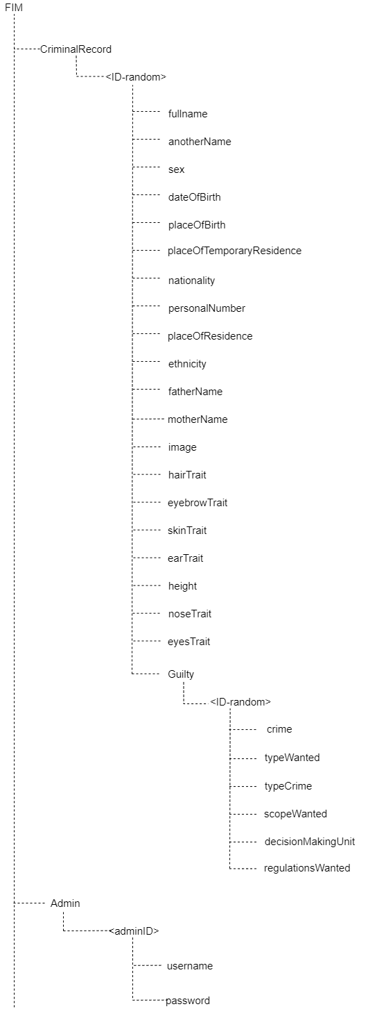

* 1. **Details**
     1. **CriminalRecord**

|  |  |  |  |
| --- | --- | --- | --- |
| **Field Name** | **Data Type** | **Note** | **Description** |
| <ID-random> | String | Not null | ID of the criminal |
| fullname | String | Not null | Full name of the criminal |
| anotherName | String |  | The nickname of the criminal |
| sex | String | Not null | Gender of criminal |
| dateOfBirth | Date | Not null | The date of birth of the crime |
| placeOfBirth | String | Not null | The birthplace of the crime |
| placeOfTemporaryResident | String |  | The temporary address of the criminal |
| nationality | String | Not null | Nationality of the crime |
| personalNumber | Number | Not null | The identity card number of the crime |
| placeOfResidence | String |  |  |
| ethnicity | String |  | The ethnicity of the crime |
| fatherName | String |  | Name of criminal’s father |
| motherName | String |  | Name of criminal’s mother |
| hairTrait | String |  | Hair trait of the criminal |
| eyebrowTrait | String |  | Eyebrow trait of criminal |
| skinTrait | String |  | Skin trait of criminal |
| earTrait | String |  | Ear trait of criminal |
| height | String |  | Height of criminal |
| noseTrait | String |  | Nose trait of criminal |
| eyesTrait | String |  | Eye’s trait of criminal |
| image | Array | Not null | Image of the criminal |
| <guilty> | String | Not null | Name of the guilty |

* + 1. **Guilty**

|  |  |  |  |
| --- | --- | --- | --- |
| **Field Name** | **Data Type** | **Note** | **Description** |
| <ID-random> | String | Not null | ID of the Guilty |
| crime | String |  | Crime of the criminal |
| typeWanted | String |  | The wanted type |
| typeCrime | String | Not null | Types of crimes |
| scopeWanted | String |  | Wanted scope criminal |
| decisionMakingUnit | String |  | Decision-Making Unit |
| regulationsWanted | String |  | Regulations wanted |

* + 1. **Admin**

|  |  |  |  |
| --- | --- | --- | --- |
| **Field Name** | **Data Type** | **Note** | **Description** |
| <ID-random> | String | Not null | ID of the admin account |
| username | String | Not null | Username of the admin account |
| password | String | Not null | Password of the admin account |